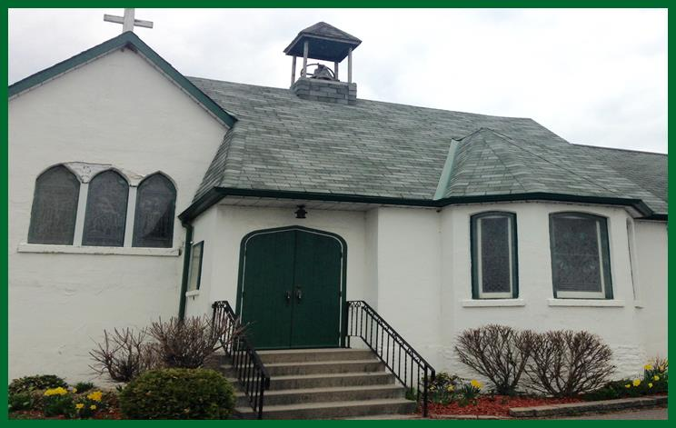
Christ Church, Glen Miller
Celebrates Its
180th Anniversary!
There will be an ACQW Parish Service
On Sunday, May 7th 9:00 am
With Bishop Michael Oulton
Potluck Brunch to Follow

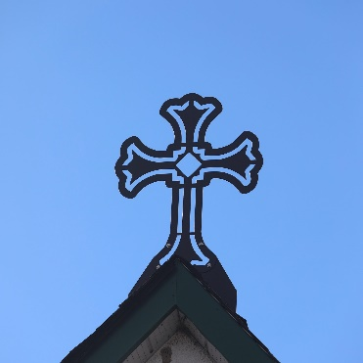
Dear Friends in Christ,
How exciting that we are celebrating another milestone anniversary in the Anglican Churches of Quinte West! I hope that you will all join with the congregation of Christ Church on May 7th to join them in raising the roof in celebration. Normally, our regular Parish Services are held on the 5th Sunday of the month, which would be April 30th. This is an exception to our regular practice. Sunday, April 30th will be a “regular” Sunday this time around. Blessings, Rev. Lynn+

Other Upcoming Events at Christ Church
Wednesday, April 26th Roast Beef Dinner Take Out $20/person For tickets 613.394.4532
Saturday, May 13th Spring Bake & Craft Sale 12pm – 2pm
Sunday, June 4th Military Wives Choir Concert 4:00pm Tickets available soon. Proceeds will be donated to “Homes for Heroes”, an initiative which assist Veterans who are homeless. This is the 180th Anniversary Outreach focus for Christ Church, for which they have already raised over $800.00.

On Saturday, April 29th an Electoral Synod will be held at
St. George’s Cathedral, for which Lay and Clergy Members
of Synod will gather to elect a new Bishop for our Diocese.
Information about the two candidates – Major the Rev. Canon
Brad Smith and the Rt. Rev. William Cliff – is available on the
Diocesan website. Hard copies of this information are available
Through our Church Office.

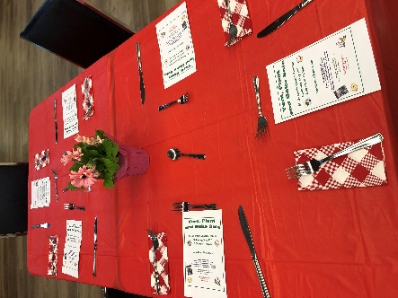

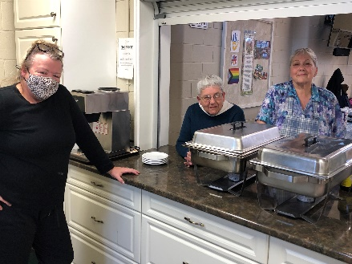

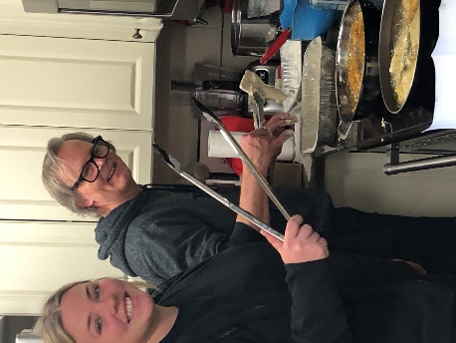
At the end of March, St. George’s hosted a sit-down fish dinner. The tables were festive, fish and the fries were crispy, coleslaw was crunchy and tasty, and the deserts were scrumptious. In short, it was an excellent dinner!
MANY THANKS to Lisa, Bill, and Abby Refausse, Bonnie McMillan, and Laura Van Meer for all their hard work.

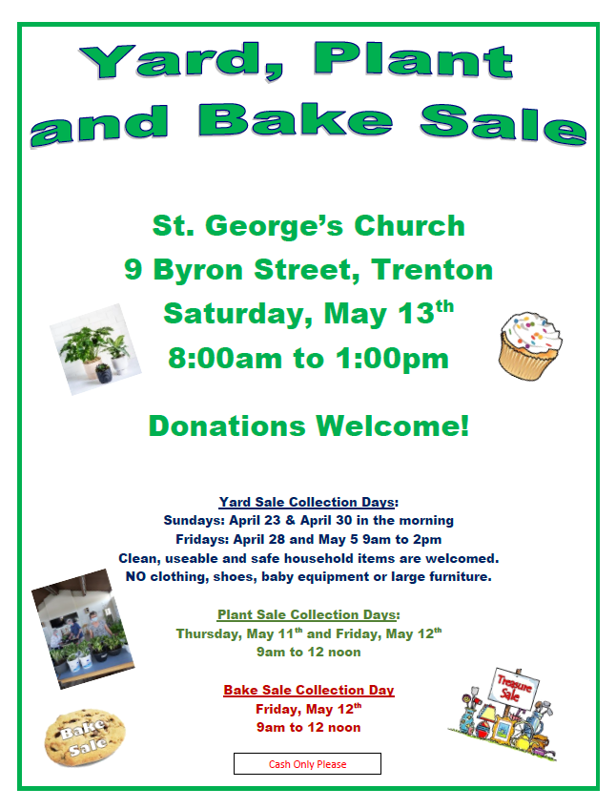

St. George’s Trenton is hosting a Yard, Plant and Bake Sale on Saturday, May 13 from 8am to 1pm in the Parish Hall. Just in time to treat your mom for Mother’s Day. Hotdogs and drinks will also be available. We are looking for donations of items for the yard sale as well as plants and baked goods. Please see the collection days as listed on the poster.

Holy Trinity operates the
Encore Thrift Shop in Frankford which is open Saturdays 9-1.
Why not drop in and have a
look for your next treasure?

St. George’s Community Lunch
The next date will be Tuesday, May 9 at 12 noon.
These healthy lunches are free to anyone
in the community and you may eat in or
take out.

April Birthdays -
Elizabeth C, Devin H, Max G, Gary P, Thorbut S, Nichola R, Ken F, Peter R, Rose H, Gerry Q, Bradley G, Heather G, William D

May Birthdays -
Peter K, LuAnn A, Jane B, Rochelle H, Al B, Min T

Al and Carma B. (April)
Edythe and Bill B. (May)

ACQW Parish Priest: The Rev. Lynn Mitchell
revlynnam@gmail.com 613.392.1466 613.394.4244 Ext.3

ACQW Office Administrator: Linda Gardiner 613.394.4244 Ext. 2
Email: stgeorgeschurch1@cogeco.net
Website: www.anglicanquinte.ca
Facebook: Anglican Churches of Quinte West, St. George’s Cemetery
YouTube: Anglican Quinte

